

|  |  |
| --- | --- |
| Report for: | Cabinet |
| Date of Meeting: | 24 January 2024 |
| Subject: | Harrow Strategic Development Partnership – Business Plans |
| Key Decision: | Yes  This is a key decision because:   1. It will result in the Council incurring expenditure in excess of £1m capital 2. It will be significant in terms of its effects on communities in all wards of the Borough |
| Responsible Officer: | Dipti Patel – Corporate Director Place |
| Portfolio Holder: | Councillor Paul Osborn  Leader of the Council and Portfolio Holder for Strategy  Councillor Marilyn Ashton  Deputy Leader and Portfolio Holder for Planning & Regeneration  Councillor David Ashton  Portfolio Holder for Finance & Human Resources |
| Exempt: | Report is public with exempt appendices  by virtue of paragraphs 1, 3 and 5 of Part 1 of Schedule 12 A of the Local Government Act 1972 as they contain information relating to any  individual; Information relating to the financial or business affairs of any particular person (including the authority holding that information); the financial or business affairs of the Council and other parties and Information in respect of which a claim to legal professional privilege could be maintained in legal proceedings. |
| Decision subject to Call-in: | Yes |
| Wards affected: | All |
| Enclosures: | Appendix 1A – HSDP overarching business plan (public version)  Appendix 1A.4 – Equality Diversity Inclusion Policy  Appendix 1A.6 – Health and Safety Policy  Appendix 1B – Overarching Business Plan (exempt)  Appendix 1B.1 – Programme (exempt)  Appendix 1B.2 - Risk and Opportunities Register (exempt)  Appendix 1B.3 - Draft Short Term Communication Strategy (exempt)  Appendix 1B.4 - Equality Diversity Inclusion Policy (exempt)  Appendix 1B.5 - Finance Policy (exempt)  Appendix 1B.6 - Health and Safety Policy (exempt)  Appendix 1B.7 - Advice Note (exempt)  Appendix 1B.8 – Construction KPI Schedule (exempt)  Appendix 1B.9 – Model Print Out (exempt)  Appendix 2A – Poets Corner Phase Business Plan Public Version  Appendix 2A.12 Development Manager 12 Month Activity Summary  Appendix 2B – Poets Corner Phase Business Plan (exempt)  Appendix 2B.1 – Poets Corner Programme (exempt)  Appendix 2B.2 – Poets Corner Planning Risk Register (exempt)  Appendix 2B.3 – Poets Corner Constraints Plan (exempt)  Appendix 2B.4 – Poets Corner site drawings (exempt) (to follow)  Appendix 2B.5a – Poets Corner Commercial leasing report (exempt)  Appendix 2B.5b – Poets Corner Supporting Letter (exempt)  Appendix 2B.5c – Poets Corner pricing summary (exempt)  Appendix 2B.5d – Poets Corner Pricing summary (exempt)  Appendix 2B.5e – Poets Corner Pricing summary (exempt)  Appendix 2B.6 – Poets Corner Cost Estimate (exempt)  Appendix 2B.7 – Poets Corner Value for money statement (exempt)  Appendix 2B.8 – Poets Corner Risk and opportunities register (exempt)  Appendix 2B.9 – Poets Corner Estate Management outline strategy (exempt)  Appendix 2B.10 – Poets Corner Stakeholder and engagement plan (exempt)  Appendix 2B.11 – Poets Corner Compliance Report (exempt)  Appendix 2C – Development Management Activities  Appendix 3A – Byron Phase Business Plan public version  Appendix 3A.13 – Byron development manager 12 month activity summary  Appendix 3B – Byron Phase Business Plan (exempt)  Appendix 3B.1 – Byron programme (exempt)  Appendix 3B.2 – Byron planning risk register (exempt)  Appendix 3B.3 – Byron constraints plan (exempt)  Appendix 3B.4 – Byron drawings (exempt) (to follow)  Appendix 3B.5 – Byron previous scheme drawings (exempt) (to follow)  Appendix 3B.6a – Byron valuation and advice (exempt)  Appendix 3B.6b Byron sales report and valuation (exempt)  Appendix 3B.6c – Byron sales report and valuation (exempt)  Appendix 3B.6d – Byron sales report (exempt)  Appendix 3B.6e – Byron sales Valuation (exempt)  Appendix 3B.6f – Byron sales valuation (exempt)  Appendix 3B.7 – Byron cost estimate (exempt)  Appendix 3B.8 – Byron value for money statement (exempt)  Appendix 3B.9 – Byron risk and opportunities register (exempt)  Appendix 3B.10 - Byron draft estate management outline strategy (exempt)  Appendix 3B.11 – Byron community and stakeholder engagement (exempt)  Appendix 3B.12 – Byron compliance report (exempt)  Appendix 3C – Byron development management activities  Appendix 4A – Byron site plan  Appendix 4B – Grange Farm site plan  Appendix 4C – Peel Road site plan  Appendix 4D – Poets Corner site plan  Appendix 5 – Milton Road update  Appendix 6 – Avison Young HSDP business plan commercial report (exempt)  Appendix 7 – Joint venture supervisor value for money report (exempt)  Appendix 8A – EQIA  Appendix 8B – Grange Farm EQIA  Appendix 9 – HSDP timeline of Cabinet decisions 2019 - 2023 |

|  |
| --- |
| Section 1 – Summary and Recommendations |
| This report provides an update on the progress of the Harrow Strategic Development Partnership (HSDP) following its establishment in August 2021; and seeks approval for the adoption of a new Overarching Business Plan and phase business plans for Poet’s Corner (Phase 1) and Byron Quarter (Phase 1), which will form the refreshed work programme for the sites.  This report also provides an update on and seeks approval of the approach for the next steps of development of the Grange Farm (Phases 2 & 3) sites, whose incorporation into the HSDP the Cabinet approved in November 2022. **Recommendations:**  Cabinet is requested to:   1. To note the progress on the core sites against the Initial Business Plan in August 21 and note the forward looking activities set out in the new Overarching Business Plan at appendix 2c and 3c in December 23; 2. To delegate authority to the Corporate Director of Place in consultation with the Deputy Leader and Portfolio holder for Planning and Regeneration to enter any appropriate contract documents and take necessary actions to enable the delivery of the activities set out in the Overarching and Phase Business Plans over the next 12 months as set out in Appendix 2c and 3c to those plans; 3. To approve the Overarching Business Plan of the HSDP; 4. To approve HSDP to spend a maximum of £1.54m on Byron Quarter (Phase 1) Phase Business Plan over the next 12 months (from the date of the Cabinet meeting) (50% being the council’s liability); 5. To approve HSDP to spend a maximum of £2.24m on Poets Corner (Phase 1) Phase Business Plan over the next 12 months (from the date of the Cabinet meeting) (50% being the council’s liability); 6. To delegate authority to determine the satisfaction of planning gateways 1 and 2, to allow the project to proceed in accordance with Poets Corner (Phase 1) Phase Business Plan to the Corporate Director of Place in consultation with the Deputy Leader and Portfolio Holder for Regeneration and Planning; 7. To delegate authority to the Director of Finance and Assurance in consultation with the Portfolio holder for Finance and Human Resources to approve and enter into any of the financial agreements and instruments required by the Members Agreement to facilitate the new Overarching Business Plans and subsequent above mentioned Phase Business Plans in recommendation 4 and 5 above; 8. To delegate authority to the Corporate Director of Place in consultation with the Leader of the Council to give the Council’s agreement to the submission by the HSDP of any planning application and any related documents or assessments for Poets Corner, Byron Quarter, Grange Farm and Milton Road; 9. To approve the next stage approach to Grange Farm (Ph 2 & 3) as set out in Paragraph 3.2.7 below and delegate authority to the Corporate Director of Place to take any decision and enter into any agreements required to deliver the next stage of the project; 10. To note progress on the Milton Road project; 11. To refer any amendments required to the 2024/25 Treasury Management Strategy to Council; 12. To delegate authority to the Director of Legal and Governance Services in consultation with the Leader of the Council to take any action necessary to ensure that the Council’s continued participation in the HSDP is at all times compliant with applicable state subsidy laws; 13. To note that the Council’s main offices will remain at Forward Drive for the foreseeable future.  **Reason: (for recommendations)**  To enable the progress of Harrow Strategic Development Partnership and Housing delivery programme to continue. |

# Section 2 – Report

2.1 Background to HSDP:

### 2.1.1 Following a competitive procurement process under the Public Contracts Regulations 2015, Cabinet approved at its meeting of 15 July 2021 that the Harrow Strategic Development Partnership should be established with the Council’s preferred development partner Wates Residential. This was the agreed delivery vehicle for Poets Corner, Peel Road and Byron Quarter Phase 1 (the Core Sites) in the Regeneration Programme. The decision was taken following a three-stage procurement and approval through Cabinet in both 2020 2021.

2.2 On 18 November 2021, Cabinet

* 1. Approved HSDP to be commissioned to carry out the demolition and redevelopment of the site at Milton Road under a Community Works Agreement; and
  2. Authorised the Chief Executive, following consultation with the Corporate Director of Community, the Leader of the Council and Portfolio Holder for Strategy, Regeneration, Partnerships and Devolution and the Portfolio Holder for Housing, to agree the terms of and formally enter into the Community Works Agreement.

2.3 On 10 March 2022, the Cabinet reviewed progress of the work of the HSDP for each site and approved the approaches for dealing with viability challenges and maximise affordable housing.

2.4 On 13 October 2022, Cabinet noted the outcome of the review of the Milton Road scheme; approved the amendment of the scheme from that commissioned by the Council to the HSDP in November 2021 and the taking of relevant steps, including applying for appropriate planning permission; and authorised the Corporate Director of Place, following consultation with the Deputy Leader of the Council and the Portfolio Holder for Planning and Regeneration and Portfolio Holder for Housing to appropriate such parts or the whole of the Milton Road and Poets Corner sites for planning purposes and to override third party rights and covenants as may be necessary.

2.5 On 17 November 2022, Cabinet noted the outcome of the review of the HSDP sites; authorised and agreed further reports on the phase Business Plans for each scheme; approved Greenhill Way as the preferred location for the Town Hall; agreed the initial Business Plan for Grange Farm (Phase 2); approved the incorporation of the Grange Farm scheme into the HSDP and the development of a planning application for Phases 2 and 3; confirmed the decision to revise the HSDP schemes; authorised officers to commission appropriate professional services and carry out preparatory and enabling works; and considered the production of a report on the economic impact of the proposals for the Greenhill Way site.

2.6 On 16 February 2023, Cabinet approved the commencement of construction of the Milton Road scheme through the HSDP; approved the final cost position and risk-sharing approach for the development of the Milton Road scheme through the HSDP; and approved the making of an amended planning application by the HSDP reducing the height of the scheme to a maximum of six stories.

**Council’s Objectives for the HSDP:**

The Council’s objectives:

### To deliver wider regeneration across the Borough via new and improved mixed tenure housing, civic and community facilities, new employment space and the enhanced use of property assets within the Borough.

### To accelerate the pace of housing delivery across the portfolio of sites.

### To secure wider economic and social benefits for local residents, including skills and training, health improvement and new employment opportunities.

### Use existing and new property assets to optimise value for the Council.

### To contribute to the delivery of well-designed, high-quality places that make a difference for communities, businesses, residents, and families both now and in the long term.

The Council’s key priorities for the Core Sites was to:

### Re provide the Civic Centre

### Provide the Civic Centre at no cost to the Councils General Fund over the period of the partnership

### Maximise Affordable Housing across the 3 sites

**Council Administration Ambition**

2.7 The Administration’s ambition for the HSDP was presented at Cabinet in November 2022. In summary the Cabinet agreed an initial business plan for Grange Farm and its incorporation into the HSDP, agreed that the Civic Centre would be removed from Peel Road with a preferred site identified at Greenhill Way. Given the height, density, tenure, and typology of previous schemes, officers were also asked to reviewed improving the height and density ratio across the schemes, making them more sensitive to their surroundings and environments. To improve the quality of the offer and look to provide more family sized accommodation where possible.

2.8 Given the additional costs of inflation and increased costs for labour and materials. Officers were asked to prioritise the most viable schemes that would benefit the residents and businesses of Harrow most. The Civic Centre site was paused to focus all resources on Poets and Byron Quarter sites.

2.9 On Byron Quarter the focus was to respond to previous public consultation feedback and reduce down the height/massing across the phase 1 scheme without fettering later phases.

2.10 On Poets Corner officers have been focussed on bringing down unnecessary height without impacting the number of new homes delivered on the site. The new proposals create height in the right places without impacting on the look and feel of the new development. A new public entrance square has been created and costs have been reduced by redesigning to avoid utility and road diversions. A key risk to the early phase of Poets is the extensive amount of infrastructure works that are required, this has been further reduced by introducing a low risk Build to Rent product for Phase 1 which create the initial Regeneration impact and allowing the later phases to be brought forward.

2.11 A review was carried out on the Milton Road development site and following this the height was reduced down by one storey to make it more in keeping with the Harrow Centre Mosque and create a gateway development for the main Poets Corner site.

2.12 Planned outcome was to improve governance across the HSDP and focus on bringing forward viable business plans for Poets and Byron Quarter.

**2.2 Background to Regeneration Ambition**

### **2.2.1 The Council’s ambitions for regeneration and the chosen approach**

### 2.2.2 The Council has set an ambitious Regeneration programme, this is to respond to the London Plan and to provide to the extensive housing need across the borough.

### 2.2.3 The Council’s current draft Regeneration Strategy covers the period from 2015 to 2026 and it outlines three core themes:

### 2.2.4 **Place -** Providing the homes, schools and infrastructure needed to meet the demands of our growing population and business base, with high quality town and district centres that attract business investment and foster community engagement.

### 2.2.5 **Communities -** Creating new jobs, breaking down barriers to employment, tackling overcrowding and fuel poverty in our homes and working alongside other services to address health and welfare issues.

### 2.2.6 **Business -** Reinforcing our commercial centres, promoting Harrow as an investment location, addressing skills shortages, and supporting new business start- ups and developing local supply chains through procurement.

### 2.2.7 The Councils’ aim is to continue to promote sustainable communities by encouraging the right type of Development and Growth throughout Harrow. This is key to the success of the Regeneration Programme, building in sufficient infrastructure across the borough that will invigorate our local economy, attract new businesses and employers to the borough improving employment, education, and work opportunities for our residents. This is intended to provide a sense of place, well -being and welcome community for all. Harrow communities are culturally diverse, and the regeneration programme will build on this success by encouraging new families and people who want to come to live, work and relax in Harrow.

### 2.2.8 At the heart of this was a determination to build good quality homes for Harrow’s people, partly through the use of the Council’s own assets. At the same time, the Council set out its’ need to develop a new Civic Centre to replace the aging and no longer fit for purpose building located on the site known as Poets Corner.

### 2.2.9 The Council reviewed which of its sites should initially be placed into the partnership and concluded that the three sites should be those at Poets Corner, Peel Road and Phase 1 of Byron Quarter.

### Poets Corner is situated to the south of Harrow and Wealdstone Station, bounded by Marlborough Hill, Railway Approach and Milton Road. The site currently comprises the existing Civic Centre complex and is approximately 11.4 acres.

### Peel Road is situated to the north of Harrow and Wealdstone station and is bounded by Canning Road, George Gange Way and Gladstone Way. It extends to approximately 1.4 acres and currently comprises Peel House Car Park and the existing Ashram Temple, which is being relocated to an adjacent site.

### Phase 1 of Byron Quarter is a 3.7acre site in the southeastern corner of the Byron Quarter Masterplan area, bounded by Stuart Road, The Byron Recreation Ground, the Belmont Trail and Christchurch Avenue.

### Plans of all the sites are appended at Appendix 4.

**2.3 Additional Sites**

### 2.3.1 Once the partnership with Wates Construction Limited was incorporated in August 2021 as an LLP, the Council had the opportunity to add further sites into the partnership for development and on the 18 November 2021 the Cabinet authorised the HSDP to be commissioned to carry out the demolition and redevelopment of the site at Milton Road.

### 2.3.2 The Council added the Milton Road development site on 25 March 2022. This is 100% affordable scheme, and the project is on site and will complete in December 2024. The scheme is being delivered through a community works agreement, with the Council entering a building contract with Wates Construction to build the new homes, which will be owned and managed within the Council’s Housing Revenue Account.

### 2.3.3 In November 2022, an update report on the HSDP was taken to Cabinet. The Cabinet approved the initial business plan for Grange Farm (Phase 2); approved the development of a planning application for phases 2 and 3; and gave authority to incorporate the Grange Farm Scheme into the HSDP. Due viability constraints the documents required to incorporate the Grange Farm Scheme into the HSDP have not been completed.

### 2.3.4 Since November 2022, work has been ongoing to address the identified viability challenges for the core HSDP sites. This is due to inflation costs that increased significantly across the UK, putting pressure on all housing delivery programmes. The HSDP’s Development Management team have also been working to address significant regulatory changes in legislation through the inclusion of second staircases and to refocus the priorities for the sites towards more family homes where possible.

**2.4 HSDP Governance**

### 2.4.1 The HSDP is a joint venture between the Council and Wates Construction Limited to deliver regeneration across the Borough on Council owned sites via mixed tenure housing, civic and community facilities and new employment space.

### 2.4.2 The HSDP is managed through a series of governance documents which set out how the HSDP is managed, roles and responsibilities as well as reporting requirements. A key requirement of the HSDP is to provide annual business plans for the HSDP (the overarching Business Plan) as well as Phased Business Plans (for the individual sites). This annual process is intended to update each member organisation of the HSDP on the progress, performance, and viability of the sites, identify activities for the next 12 months and agree budgets for the work. Due to the uncertainties across the development sector over the last 18 months with inflation and regulatory changes, an annual business plan was not provided in 2022. The Overarching Business Plan is the first update since the Initial Business Plan was adopted in August 2021. The Phased Business Plans are the first that have been received since the inception of the HSDP.

### **2.5 Business Plans**

2.5.1 The Business Plans attached to this document set out the present position on:

* Proposals for the redevelopment focussing on two of the core sites
* The pausing of Peel Road due to viability challenges and rephasing of the programme to prioritise Poets Corner along with Byron Quarter
* The opportunity for the development of 1,265 units
* Split of affordable housing
* Approaches to ways of working including a partnership charter, board arrangements and HSDP resourcing
* Social value approach and targets
* Financial models demonstrating viability, funding strategy and projected returns
* Planning strategy and design principles
* Programme
* Community Engagement
* Approach to equalities and Inclusion

2.5.2 As some of this information is commercially confidential, part of the Business Plans are in the exempt portion of the report.

**2.6 Overarching Business Plan overview**

2.6.1 The current HSDP Portfolio comprises four sites: Byron Quarter (Phase 1); Peel Road; Poets Corner, and Milton Road (opposite Poets Corner). Appendix 4 provides an outline of the various site locations.

2.6.2 Development is challenging to the most experienced of developers, over the past 3 years the UK inflation rates have increased significantly creating a difficult financial environment for many developers. During this time the HSDP has reviewed its portfolio of sites, rephasing them to create a more secure delivery mechanism for the programme this has been achieved by the following activities.

2.6.3 Concurrently to this and following the pandemic and administration change the Council carried out a review of its accommodation requirements this outlined that the Council no have an urgent need for a Civic Centre. The Peel Road project was delayed due to viability issues and therefore, the Council staff will remain at Forward Drive for the foreseeable future. The Council emergency front door has now been relocated to its new offices at Gayton Rd. The above changes have allowed the HSDP to focus its resources onto Poets Corner (Ph1) and Byron Quarter (Ph1).

2.6.4 Poets Corner (Ph1) subject to obtaining the necessary planning permission is proposed to create new homes, community open spaces with public square, park and new homes in the heart of Harrow. It is proposed to provide a retail offer and create excellent navigation from Station Road to Harrow and Wealdstone station.

2.6.5 The Byron Quarter (ph1) responds to resident's comments on earlier phases and is proposed to provide new affordable family size accommodation which responds well to the existing environment in Byron Park.

2.6.6 Milton Rd has been incorporated into the HSDP o kickstart the regeneration of Poets Corner and provide much needed affordable homes in Harrow.

**2.7 Byron Phased Business Plan Overview**

2.7.1 The proposed new low-rise housing development will consist of 149 new homes with access via the Leisure Centre carpark and landscaping. It is proposed to feature 27% Affordable Homes (by habitable rooms – subject to viability), 78 apartments and 71 houses which equates to 30% by unit.

The main changes from the previous scheme proposal includes:

* + Review of height and density reducing the density across the scheme from the previous 11 storey scheme
  + Introduction of more family houses
  + Increased proportion of family housing in particular for the Affordable
  + Creation of better-quality housing, through good design and placemaking.

2.7.2 The scheme needed to respond to the other challenges set out below:

* + Addressing regulatory changes, specifically in relation to fire-safety and sustainability hence all buildings are below the threshold for two-staircases.
  + Adjusting for movements in cost, largely relating to regulatory changes not originally anticipated and abnormal inflation from 2022 – hence much of the development is now housing which can be traditionally constructed which is more cost-effective.
  + Rising interest rates, impacting the cost of debt and mortgage lending – hence much of the development is now housing which can be sold in a shorter period, reducing peak debt and the duration of borrowing.

2.7.3 The current scheme responds more strongly to the aspirations agreed by Cabinet in November 2022 as it is now predominantly traditional housing with a single flat-block of 6-storeys (max. height) while concurrently resolving the other challenges outlined. As a result of introducing more houses, there are now additional ‘front-doors’ onto the public realm to assist in placemaking and passive surveillance.

Below sets out previous proposed scheme (August 2021) and the current proposed scheme (October 2023):

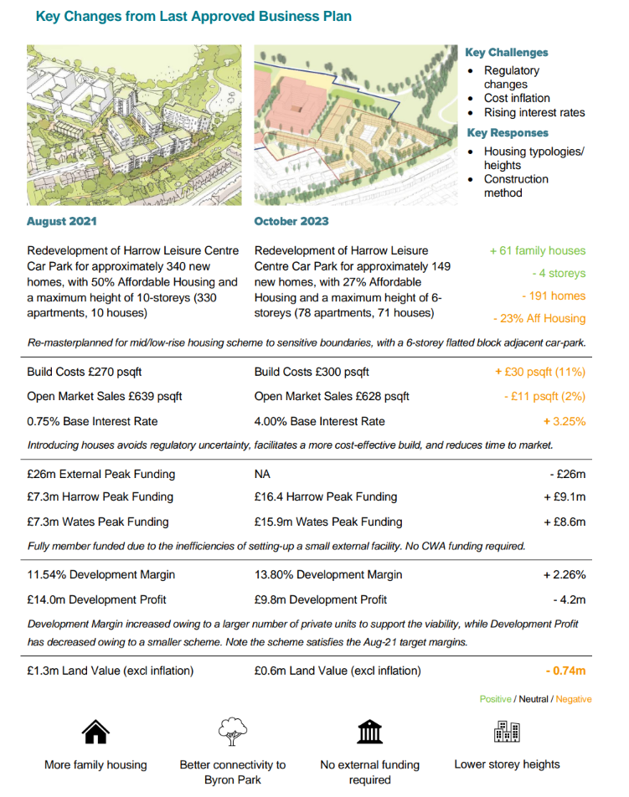

**Next Steps:**

The Byron Phase Business Plan will be adopted along with v117 of the Financial Model this includes £1.54m of expenditure for the next 12-months:

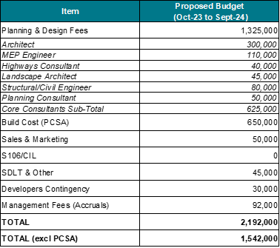

**Item**

**Proposed Budget**

**Jan to Dec 24**

2.7.4 The new proposals on Byron Quarter will provide much needed new family sized homes in Harrow and it will increase the diversity of sales products and routes to market for the HSDP.

**2.8 Poets Corner Phased Business Plan overview**

2.8.1 The proposed development currently consists of approximately 1,100 new homes including 15% AH (Affordable Housing) across all phases, 14,000 sqft of commercial with associated access and landscaping.

2.8.2 It is currently proposed to be brought forward in three phases with Phase 1 delivering over 532 new homes Build to Rent (BtR) with a current assumption of 6% or 30 units for Affordable Discount Market Rent.

2.8.3 The scheme is based around a street-based masterplan with a series of open spaces with the majority of the existing trees remaining to create a green space (Poets Garden). The proposals include a high street square, multiple block courtyards, as well as a series of indoor amenity spaces for residents.

2.8.4 Given the proximity to public transport and the development has a focus on pedestrians, providing easy navigation through utilising landscape and open spaces and public square to enable residents and visitors to find their destination point.

2.8.5 Building heights vary from 3 to a single maximum 15-storeys block at the Northeast corner of the site which is a reduction of 2 storeys from previous proposals.

2.8.6 Below sets out previous proposed scheme (August 2021) and the current proposed scheme (October 2023):

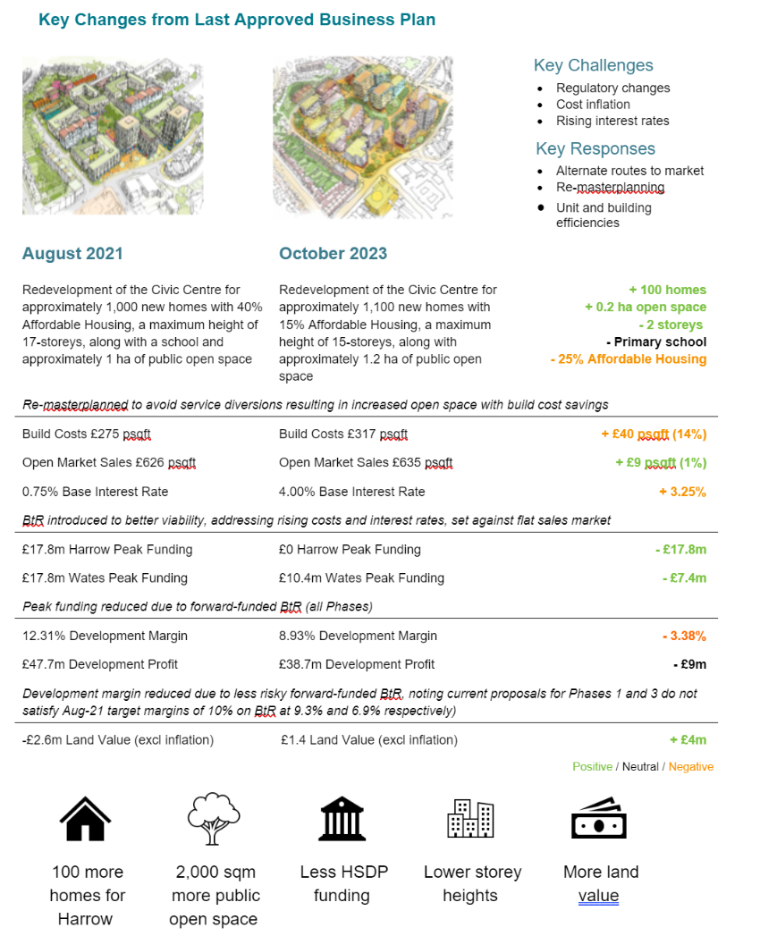

**Next steps:**

The Poets Phase Business Plan will be adopted along with v117 of the Financial Model this includes £2.24m of expenditure for the next 12-months:

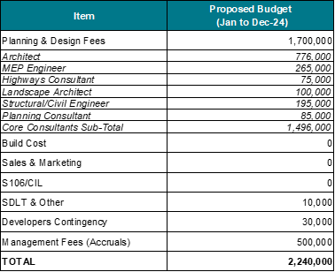

2.8.7 The new proposals will kickstart the wider regeneration of Poets Corner, an important strategic site, proposing to deliver c1,100 new homes including Affordable Homes and c14,000 of commercial space. Phase 1 will reduce the risk on the delivery of later phases by forward funded providing Build to Rent and reducing upfront enabling costs.

2.8.8 Over the next 12 months the design team will explore further opportunities to improve the affordable numbers across the site increasing the affordable homes to a minimum of 20% by seeking additional grant funding, the allocation of existing grant and improving the design to be more efficient as part of the design development.

2.8.9 Due to the size and complexity of the site, the proposal is that the Poets Corner Phase 1 detailed design and planning application will be brought forward as part of the wider Outline planning application for the entire site which will place obligations on Phases 2 and 3. The rationale will be to create a masterplan for the entire Poets Corner site creating a new place and anchor location for residents, businesses and visitors to Harrow.

**3.0 Additional Sites**

**3.1** **Milton Road Update**

3.1.1 The Milton Road site adjoins Poets Corner; the site was incorporated into the HSDP via a Community Works Agreement (CWA) in March 2022. Following the 2022 administration leadership change, the height of the apartment building was reduced from 7 to 6 storey improving its relationship with the emerging Poets Corner masterplan. This was changed as part of a Minor Material Amendment (MMA/s.73) to the existing planning permission.

3.1.2 Milton Road project is currently on site, all activities are on programme, the final due for completion in 2024 will deliver 36 new Affordable homes with a mixture of houses and apartments for Social Rent and Shared-Ownership.

**3.2 Grange Farm Update**

3.2.1 The design and delivery of Phases 2 and 3 of the Grange Farm Estate Regeneration was put to HSDP partners as a potential Future Opportunity in mid-late 2020. Wates prepared a proposal for the HSDP to undertake the project with a proposal issued to Harrow in December 2020. The HSDP was granted an exclusivity period to prepare a Phase Business Plan (PBP) for Harrow’s consideration.

3.2.2 In October 2022 the HSDP board submitted a PBP to Harrow Council and made recommendations as follows:

* Agree the initial PBP for Grange Farm (phase 2)
* Incorporate the scheme into the HSDP
* Proceed to develop a planning application for Phases 2 and 3

3.2.3 These recommendations were subsequently approved at the 17 November 2022 Cabinet.

3.2.4 The HSDP instructed a core project team of consultants from Dec 2022 to develop the proposals and undertake the pre-planning consultation.

3.2.5 The necessary legal agreements to add Grange Farm to the portfolio were subsequently drafted and were in the final stages of production in June 2023.

3.2.6 It was confirmed by LBH representatives at the HSDP board meeting of June 2023 that work on Grange Farm should be paused for a period in order to prioritise and focus on the core sites with updated business plans in accordance with the HSDP agreement.

3.2.7 Following a thorough review of the scheme, the planned next steps are:

a) to restart Grange Farm (Phase 2 and 3) and proceed to a planning application;

b) concurrently, the Council to investigate different construction delivery routes to for delivery stage of the project to demonstrate Best Value and to bring pace to this programme.

## 4.0 Climate Change, Nature Recovery and Sustainability

4.1 The Overarching Business Plan acknowledges that, as a vehicle for major development in the borough, HSDP has a crucial role to play in contributing to each of the four key themes of the Borough’s strategy.

4.2 This includes energy efficient buildings that incorporate circular economy principles into their construction methods, encouraging sustainable modes of transport in the borough such as walking and cycling, and contributing to achieving biodiversity net gain on sites.

4.3 The primary method of heating will be via electric heat pumps with an ambition to meet the remaining 5% peak loads by direct electric top up subject to grid capacity and end user costs testing. Electrically based heating will allow the developments to benefit from the continuing decarbonisation of the national grid over coming years and ultimately achieve net zero carbon operational energy.

## 5.0 Social Value

5.1 The HSDP and council officers have undertaken a full review of Social Value. The HSDP Social Value Manager (SVM) will lead on all the social value activities and will measure these activities on the Social Value Portal (SVP).

5.2 A Social Value Strategy will set out the proposed activities and opportunities to promote social value and growth across the Borough, this will be updated regularly reporting on actions from the HSDP’s programme these include providing:

* New Apprenticeships
* New jobs created for local residents
* Careers, advice & guidance (including site visits)
* Upskilling for the existing workforce
* Work Experiences opportunities
* Payment of London Living Wage
* Volunteering by Wates and Supply Chain staff
* Spending with local SME’s and micro-businesses to include all associated business sectors during the design and build process, to ensure local businesses benefit from construction and all the other opportunities generated in the developments.
* Tree planting and other environmental initiatives that support the Climate Change and Nature Recovery Strategy and Harrow’s Green Flag Parks.

5.3 The HSDP supply chain is key to support the use of local labour, therefore the HSDP team will work with their subcontractors before the tender stage promoting local employment and recruitment of local apprentices.

5.4 The target outputs will be delivered by Wates, their supply chain and in partnership with key stakeholders. All consultants and subcontractors ill be required to submit monitoring forms demonstrating compliance with the social value programme, providing progress updates, sharing successes and highlighting any concerns with updates reported monthly to the HSDP Board.

**Social Value Key Themes**

5.5 The Social Value programme for the HSDP has been developed around the following key themes:

* Employment and Training
* Supporting the Community
* Supporting Local Businesses
* Other Social Value Commitments Exceeding Expectations
* Additional Projects

## Monitoring and Reporting

5.6 Wates Residential internal collection document is the Community Investment Plan (CIP). The CIP captures all the delivery data in one place.

5.7 Quarterly reports and detailed Project Impact Report (PIR) will be prepared midway through the project. Underperformance will be addressed at quarterly review meetings. The SVM will conduct monthly update meetings with Harrow colleagues.

5.8 The Social Value Portal (SVP) can be used to calculate the impact / social value added from the activities undertaken. However, the real impact will be measured by the number of jobs created residents into work, apprenticeships created and completed and local spend with Harrow suppliers.

5.9 The SVP is an online solution that allows organisations to measure and manage the contribution that they and supply chain makes to society, according to the principles laid out within the Public Services (Social Value) Act 2012 & PPN 06/20.

5.10 Their solution allows organisations to report both financial and non financial data and rewards organisations for doing “more good” in the community. The SVP calculates the impact using the unit cost database 2.0 version, as its proxy bank.

5.11 Monitoring returns will include data against the 9 Protected Characteristics, to ensure underperformance is picked up and addressed.

## Overall SV Targets

5.12 In establishing these targets, a key focus area on delivery is on helping unemployed, under-employed and those furthest from the job market as well as actively engaging with schools and colleges to engage young people in the career opportunities available through the apprenticeship routes and entry level roles.

5.13 All community benefit will be delivered within Harrow’s existing infrastructure of skills, employment, education and community. Our SV commitment for the project includes:

* Over 180 apprenticeships created with over 45 of those for unemployed / furthest from the job market
* Over 300 new jobs created with over 50 of those for unemployed / furthest from the job market, noting that a job requires at 26 continuous weeks to be counted.
* Over 180 work experience opportunities
* Over 500 volunteering hours by Wates and Supply Chain staff
* Over 70 workshops to support Community Voluntary Organisations The content of those workshops to be agreed prior to their delivery.
* Over 10 business mentoring sessions and business skills sessions

5.14 At the end of each year the performance will be reviewed and the forecast for the following year amended as necessary to ensure a steady flow of opportunities and activities throughout the lifetime of the project, keeping local residents engaged and building on the opportunities available.

## Social Value Funding Approach

5.15 The Social Value offer is driven through Wates and the Supply Chain offering ensuring that the programme is delivered without the requirement for additional funding by the Council or any financial impact upon the Councils returns or land value.

### **6.0** **HSDP Next steps**

6.1 Following Cabinet agreement, the HSDP’s Development Manager will proceed on the design development of the two core sites Poets and Byron (ph1).

6.2 The Byron Quarter and Poets Corner Phase Business Plans set out the activities that will be progressed to bring forward the sites for development. In particular the business plans outline the required budget for the next 12 months to progress with the detailed design and planning applications for both sites.

6.3 The Byron Quarter business plan has set a target date to submit a planning application by May 2024 with an expectation to have planning determined by the end of 2024 including any judicial review period. While the principles of design for Byron Quarter are progressed, the HSDP will undertake the detailed design and technical work required in the coming months to before submitting for Council approval the proposals that will be put forward for planning. This currently scheduled for April 2024, and as per the Development Agreement, the Council will have 15 days to provide any comments in relation to the proposed planning submission.

6.4 Once a successful planning outcome has been achieved, it is expected that the HSDP will then enter in a Preconstruction Services Agreement with Wates Construction to undertake detailed design work enabling start onsite in July 2025.

6.5 The Poets Corner business plan has set out some challenges that need to be overcome before a commercially agreeable development proposition for entire site can be progressed to planning. To demonstrate this, requires a number of workstreams and activities to be undertaken to develop the proposals further providing confidence to both partners that future expenditure should be authorised.

6.6 As such the Poets Corner business plan sets out some key gateways, which have approved budget allocations against them. At the end of each gateway the HSDP board will be required to provide approval for the next stage to be commenced based on the progress that has been made by the Development Manager in developing a commercially acceptable proposal. Should the HSDP be satisfied at each gateway that there is confidence in the proposals then work can proceed, otherwise a further decision will need to be made around next steps. This process is designed to ensure that there is greater oversight of expenditure and progress while limiting any abortive work undertaken should a commercially viable solution not be arrived at.

6.7 The next stage activities are set out in the HSDP Business Plans with the 12-month gateway proposals outlined within the Poets Corner Phase 1 Business plan.

## 7.0 Environmental Implications

7.1 The activities of the HSDP are intended to provide significant environmental benefits as the developments will be to high environmental and sustainability standards. Appropriate environmental assessment will take place on each scheme through the planning process.

7.2 The developments will remediate inefficient and poor environmental quality buildings and brown field sites.

## 8.0 Risk Management Implications

The HSDP risk is included in the Corporate Risk Register and will be updated to reflect the risks highlighted in this report.

The Procurement Risk Register is coming to an end. HSDP Risk Register will be determined and monitored by the board. Risks below relate to this decision to establish the HSDP.

The relevant risks contained in the register are attached/summarised Below. The following key risks should be taken into account when agreeing the recommendations in this report.

| **Risk Description** | **Mitigations** | **RAG Status** |
| --- | --- | --- |
| Business Plans fail due to the loss or withdrawal of GLA funding | * On-going meetings with GLA on funding | **Amber** |
| Business Plans fail due to deeper weaknesses in the Partnership such as contract or cost claim disputes or to development management failures | * Legal review of cost claim * HSDP Strategic Board in place * Contract review of DM function & associated activities | **Amber** |
| The Business Plans’ underlying key assumptions turn out to be inaccurate, unsound or invalid | * Robust Financial Management with external independent advise | **Amber** |
| The Council does not receive best consideration for its assets in accordance with s123 LG Act 1972 | * The Council will carry out a S123 valuation on their land prior to drawdown to ensure best value is demonstrated. | **Green** |
| Inadequate Governance & Assurance | * All formal decisions made by the Council in respect of the HSDP are subject to the Council’s normal decision -making process * HSDP Delegations Policy * HSDP Procurement Policy * Financial structure * Legal structure * Business Plans * Cabinet and Overview and Scrutiny oversight * GARMS involvement as appropriate | **Amber** |
| HSDP Partnership breaks down and company dissolved | * Continual engagement with partner to ensure relationship is maintained | **Amber** |
| Decisions made by the HSDP are inappropriate/ do not represent VfM/ lead to financial loss | * Decisions must be in-line with Business Plan * Delegations policy containing limits on decisions to be made by the HSDP * Involvement of Cabinet in particular decisions e.g. changes to the Business Plan * Client -side monitoring | **Amber** |
| Inadequate skills on the Client Side to monitor HSP performance and control risks | * The Council has a new team structure to meet the needs of the partnership and will go out for appointment shortly. | **Amber** |
| Political change of administration or approach within Administration | * Regular briefings * Contingency planning * Appropriate legal mechanisms | **Amber** |
| Planning risk   * political risk * regulatory change | * Regular briefing with political groups to continue * Risk allowance for climate change and energy strategy changes * Developer and contractor contingency included in financial model | **Amber** |
| Programme change or delay leading to increased costs.   * Professional team   Market changes/Interest | * Prompt decision making in accordance with the delegation policy * Avoid scope change * Market and economy monitoring | **Amber** |
| Financial viability   * Cost increase * Revenue risk – market * Land value * Cost overruns | * Continued viability review * Business Plan review * Option to consider changes to: * design – massing and density * Tenure * Value engineering * Alternative funding * Changes to programme via phasing or delay * Cost management pre and post construction using all available mitigations | **Amber** |
| Failure to achieve financial profiling | * Establishment of effective Council client side for monitoring and reporting * Regular partner meetings | **Amber** |
| Commercial partner   * Change in direction * Stability | * Engagement with commercial partner * Monitor market and media * Use professional networks and advisers | **Green** |
| Failure to deliver a viable scheme on Poets and impact on delivery of Byron Quarter | * All Byron Quarter design and planning can be reused for delivery through other means * Derisking Phase1 Poets with predominately BtR product | **Amber** |

**9.0 Legal Implications**

9.1 Vires

9.1.1 (i) Power to participate in the HSDP, under s.1 Localism Act 2011 the Council has power to do anything that individuals generally may do, (known as the ‘General Power of Competence’). Whilst the Act goes on to provide at s.4 that where a Council is carrying out activities for a commercial purpose it must do so through a company, the case of Peters v Haringey (2018) clarified the position with regard to local authorities’ participation in a Limited Liability Partnership such as HSDP.

This case established the principle of the ‘dominant purpose test’, which is an examination of the principal motivation of the local authority, (irrespective of the motivation of other participants), in entering into an LLP.

Where that motivation is principally commercial, activities will need to be undertaken through a company structure. However, where the dominant purpose is not commercial, local authorities are empowered to participate in an LLP.

The objectives established by the Council at the time of the procurement demonstrate that the dominant purpose of the Council’s participation in HSDP are not for a dominantly commercial purpose and therefore that the Council has the power to participate in the HSDP as an LLP structure.

9.1.2 (v) Power to invests.12 of the Local Government Act 2003 gives a local authority the power to invest for any purpose relevant to its functions under any enactment, or for the purposes of the prudent management of its financial affairs.

9.1.3 ‘Functions' can include all duties and powers of the Council, including statutory functions to benefit and improve its area and to promote its area's economic development. In using this power, the Council must have regard to relevant statutory guidance and comply with its approved and published investment strategy and ensure that it keeps within the parameters of an investment role. This provides the Council with the power required to invest funds envisaged by the Business Plans.

9.1.4 The Council’s advisors, Pinsent Masons LLP, have advised previously that provided the HSDP transactions are on market terms, they will confer no selective economic advantages and therefore will not breach state subsidy rules. Officers are cognisant of the need for the business plans and the activities carried out under them and the HSDP arrangement itself to comply with UK subsidy law and full advice will be obtained on an ongoing basis to ensure the continued lawfulness of the HSDP and the activities carried out by it.

**10.0 Financial Implications**

**Overall Business Plans**

### 10.1 In approving the HSDP business plans as presented as part of this report the Council is being asked to approve further expenditure to be incurred by the Development Manager as per the delegation's policy.

### 10.2 The HSDP financing arrangements mean that Wates Residential are required to cashflow all pre-construction expenditure and as such there has been no cashflow implications for the Council as a result of the expenditure incurred by the HSDP to date. Similarly, by Cabinet approving the business plans presented, which include further HSDP expenditure of £1.54m for Byron Quarter and £2.24m for Poets Corner, there are no cashflow implications for the Council.

10.3 As of 30th November 2023, the management accounts for the HSDP show expenditure of £8.6m for all sites in the HSDP excluding Milton Road which is directly charged to the HRA.

### 10.4 Whilst there are no cashflow implications for the Council, as equal partner within the HSDP, the Council is in effect underwriting 50% of any expenditure that is incurred, such that should any costs become abortive, the Council would have to contribute to costs incurred (subject to reason for abortive costs being realised). As such it is important for the Council to have confidence that there are robust business plans in place that will lead to delivery of the development proposals and expenditure will be controlled and monitored in a robust manner and value for money achieved at all stages of the development cycle.

10.5 Therefore, with total spend of £8.6m to date and further spend required of £3.78m (£1.54m for Byron and £2.24m for Poets), this brings the total cost commitment to £12.4m of which the Council would be liable for 50% of these costs should the schemes not progress and costs therefore become abortive.

**Over the next 12 months, grant funding will be applied for but at this stage the Business Plans include no grant funding.**

**Byron Quarter**

10.6 The HSDP business plan for Byron Quarter requires the partners to fund the entire development through member capital (equity contributions from the partner) and not procure third party debt. Given the current interest rate environment, it is not considered optimum to the HSDP to procure debt from the capital markets and while this will be kept under review, currently it is deemed accretive to the development for the members to fund the development.

### 10.7 The Council’s share of equity for Byron Quarter is currently forecast to be £15.7m (with spend profiled across 2025/26 and 2026/27) as set out in the Table below. It should be noted that this number is uninflated and therefore as future business plan updates are received this number is subject to change.

10.8 The following table shows the financial summary of Byron Quarter and shows the investment of £15.7m over 2 financial years, plus the financial return over 3 financial years, plus anticipated dividends and interest on investment and land due to the Council.



10.9 The Council will finance the £15.7m through it’s cash balances and therefore it will not be necessary to take out PWLB borrowing to fund this short-term investment in the HSDP. The cash balances will be reinstated once the equity is repaid.

10.10 The Council’s returns will be in the form of land receipts and profit distributions. For Byron Quarter it is forecast that this will be [£0.953m and £4.940m] respectively as set out above. The Council will also receive interest on its equity investment into the HSDP, which is currently assumed to be charged in at 9.5%, totalling £2.1m. Both the profit and interest payments would be treated as one off revenue benefits to the General Fund but have not been built into the MTFS at this stage.

10.11 The Council invests cash balances as part of its Treasury Management activities. The cash balances are currently achieving average returns of 5%. Therefore, the £1.9m the council would receive as interest on the £15.7m equity investment (which averages a 9.5% return), more than covers the 5% investment income lost from investing cash balances as part of our Treasury Management activity. The Annual Treasury Management Strategy which will be agreed by Cabinet in February 2024, and will be updated to include references to the HSDP and short-term equity investment to be made in Byron Quarter.

**Poets Corner**

10.12 For Poets Corner, the business plans set out proposals for a 100% build to rent scheme, which would be forward funded by an investor during the construction stage. As such there is no additional equity requirement for the Council currently required for Poets Corner.

10.13 As set out earlier, the Poets Corner business plan needs further work to develop a commercially viable and acceptable business plan. The current proposals do not achieve the HSDP’s target return requirements and provide a nominal land value to the Council. While the HSDP business plans set out the current forecast returns for Poets Corner, these will need to optimised before the development can proceed.

10.14 The Council in approving the business plans, is in effect approving

The following expenditure across the next 12 months (subject to gateway approvals):

Gateway 1 – expenditure budget of £437k

Gateway 2 – expenditure budget of £830k

Total 12-month budget £2.2m

10.15 Should the Poets Corner business plans be paused after each of the Gateway milestones, 50% of any expenditure incurred will be abortive if the scheme does not proceed through the HSDP. Should the Council choose to not approve the business plans then this amount would immediately become abortive.

### **10.16 Financial Risk**

10.16.1 With regeneration being the key objective, the Council accepts there is a higher risk on capital investments in the HSDP than with treasury investments where the emphasis is on Security, Liquidity and Yield (SLY) in that order. The principal risk exposures for regeneration scheme would be a fall in sales values and high inflation impacting build costs.

### **10.17 Additional Professional Fees**

### 10.17.1Avison Young (Commercial Advisors) and Pinsent Masons LLP (Legal Advisors) will continue to provide independent support to the Council on the HSDP to ensure that the Council is making best use of the resources and funding in the development of the HSDP Programme.

### **10.18 Financial Delegations**

### 10.18.1This is also a risk mitigation factor with key decisions reserved for the Council based on the Delegation Policy in the Members Agreement.

## 11 Equalities implications / Public Sector Equality Duty

11.1 When taking decisions, local authorities must have due regard to The Public Sector Equality duty contained in section 149 of the Equality Act 2010.

11.2 The Harrow Strategic Development Partnership is being formed to deliver the Council’s regeneration ambitions on the three core sites. These objectives, particularly in terms of the acceleration of the pace of housing delivery are specifically targeted at creating benefit for all of Harrow’s diverse communities. Therefore, to ensure that the impacts on communities, and particular groups are understood, and how the Harrow Strategic Development Partnership can maximise benefits to Harrow residents, Equalities Impact Assessments (EQIAs) will be carried out accordingly on a project by project basis on all scheme Business Plans and proposals.

### 11.3 In terms of this decision, the closing of contracts and the establishment of the HSDP an EQIA was carried out as part of the Cabinet report recommending the setting up of a Development Partnership in May 2019. A further EQIA’s are attached to this report for the development of the two core sites and the continuation of Grange Farm project please see Appendix 8.

### 11.4 The LLP documentation requires the Harrow Strategic Development Partnership to comply in all respects with legislation and good practice.

### 11.5 At this stage the Business Plan outlines high level plans for engagement and specific approaches for groups with protected characteristics, and an approach to inclusive design which will give high standards in compliance with relevant legislation.

### 11.6 The Equalities Implications for the Accommodation Strategy which includes the development of the new HNC as proposed in this Business Plan, and the move from the existing Civic Centre are attached as Appendix 8.

## 12 Council Priorities

12.1 The activities of the HSDP will support the Councils ambitious Corporate Plan to restore pride in Harrow alongside the three priorities ensuring these are at the heart of everything the Council does to deliver services for Harrow residents and businesses.

The three priorities are:

* A council that puts residents first
* A borough that is clean and safe
* A place where those in need are supported

12.2 Harrow is vibrant and richly diverse borough and continuing to grow as a great place to live, learn, work and visit. With excellent schools, a thriving local economy and outstanding parks and green spaces. The Council is proud of the character of our borough and committed to creating more quality family homes supported through excellent development.

### 12.3 There is a growing need and demand for more housing in Harrow and therefore imperative that we build new homes, particular affordable homes through the HSDP. The three core sites where building will take place are all strategically linked to the transport hub of Wealdstone so will enable investment in infrastructure to connect and support residents now and in the future.

# Section 3 - Statutory Officer Clearance

**Statutory Officer: Sharon Daniels**

Signed by the Chief Financial Officer

**Date:** 12 Jan 2024

**Statutory Officer: Jessica Farmer**

Signed by the Monitoring Officer

**Date:** 12 Jan 2024

**Chief Officer:** **Dipti Patel**

Signed by the Corporate Director

**Date:** 12 Jan 2024

**Head of Procurement: Nimesh Mehta**

Signed on by the Head of Procurement

**Date**: 8 Jan 2024

**Head of Internal Audit: Neale Burns**

Signed on behalf of the Head of Internal Audit

**Date:** 16 Jan 2024

**Has the Portfolio Holder(s) been consulted? Yes**

## Mandatory Checks

### Ward Councillors notified: YES

### EqIA carried out: YES

### EqIA cleared by: Jennifer Rock

# Section 4 - Contact Details and Background Papers

**Contact:** Emma Talbot, Director Regeneration and Sustainable Development: [Emma.Talbot@harrow.gov.uk](mailto:Emma.Talbot@harrow.gov.uk)

**Background Papers:**

<https://harrowintranet.moderngov.co.uk/ieDecisionDetails.aspx?ID=62857>

[Decision - Milton Road - Modern Council (moderngov.co.uk) - 16/02/23](https://harrowintranet.moderngov.co.uk/ieDecisionDetails.aspx?ID=62996)[Decision - Harrow Strategic Development Partnership (HSDP) - Review and Progress - Modern Council (moderngov.co.uk) - 17/11/2022](https://harrowintranet.moderngov.co.uk/ieDecisionDetails.aspx?ID=62960)

[Decision - Milton Road Development - Review and Update - Modern Council (moderngov.co.uk) - 13/10/22](https://harrowintranet.moderngov.co.uk/ieDecisionDetails.aspx?ID=62950)

[Decision - Harrow Strategic Development Partnership (HSDP) Update - Modern Council (moderngov.co.uk) - 10/03/2022](https://harrowintranet.moderngov.co.uk/ieDecisionDetails.aspx?ID=62912)

[Decision - Milton Road Development - Transfer to Harrow Strategic Development Partnership - Modern Council (moderngov.co.uk) - 18/11/21](https://harrowintranet.moderngov.co.uk/ieDecisionDetails.aspx?ID=62884)

[Decision - Harrow Strategic Development Partnership - Contract Close and Establishment - Modern Council (moderngov.co.uk) - 15/07/21](https://harrowintranet.moderngov.co.uk/ieDecisionDetails.aspx?ID=62857)

[Decision - Harrow Strategic Development Partnership - Appointment of Preferred Bidder - Modern Council (moderngov.co.uk) - 10/09/20](https://harrowintranet.moderngov.co.uk/ieDecisionDetails.aspx?ID=62782)

[Decision - Harrow Strategic Development Partner - progress update - Modern Council (moderngov.co.uk) - 13/02/20](https://harrowintranet.moderngov.co.uk/ieDecisionDetails.aspx?ID=62745)

[Decision - Harrow Strategic Development Partner - Modern Council (moderngov.co.uk) - 10/10/19](https://harrowintranet.moderngov.co.uk/ieDecisionDetails.aspx?ID=62706)

[Decision - Any Other Urgent Business - Call-In of the Cabinet decision (30 May 2019) - Harrow Strategic Development Partnership - Modern Council (moderngov.co.uk) - 20/06/19](https://harrowintranet.moderngov.co.uk/ieDecisionDetails.aspx?ID=62672)

Call-in waived by the Chair of Overview and Scrutiny Committee: **NO**